Database Management System

SPOTIFY CLONE

Final Project

Authors: Wahaj Ahmed, Muhammad Umair  
Enrollment: 01-134221-086, 01-134221-054  
Instructors: Sir M. Siddique, Ma’am Sara Durani  
Date: 4th January 2024

Contents

Abstract

Introduction 2.1 Domain Introduction  
2.2 Project Motivation  
2.3 Scope  
2.4 Technical Prerequisites  
2.4.1 Programming Languages  
2.4.2 Database Design

Database Design 3.1 ER Diagram & Relational Schema  
3.2 Entities Description  
3.3 Relational Diagram Description

Implementation 4.1 Front End  
4.2 Back End  
4.3 Important HTML & CSS Used  
4.4 Important PHP Used  
4.5 Important JavaScript Used

Accessibility 5.1 Installation of VS Code  
5.2 Installation of XAMPP  
5.3 Basic CSS Files  
5.4 Link to GitHub

Results 6.1 The Final Creation  
6.2 Conclusion

Future Enhancements

1. Abstract

The 'Spotify Clone' project is an ambitious web application aiming to emulate the diverse functionalities of Spotify. Constructed using a tech stack that includes Laravel, JavaScript, HTML, CSS, PHP, and XAMPP, this dynamic platform encompasses user registration, login capabilities, a comprehensive music dashboard featuring playlists, artist profiles, and even a subscription model. The primary goal is to deliver an immersive music streaming experience while showcasing adeptness in database management and web development.

2. Introduction

2.1 Domain Introduction

The Spotify Clone project ventures into the dynamic domain of music streaming, offering users a platform inspired by the popular Spotify service. The application provides a familiar yet distinct interface, utilizing cutting-edge web technologies to ensure a captivating and user-friendly experience.

2.2 Project Motivation

Motivated by a deep passion for music and a desire to create an impactful learning experience, the Spotify Clone project is a testament to the fusion of technology and artistic expression. It strives to rekindle users' enthusiasm for music while marking a significant milestone in the journey of both front-end and back-end development.

2.3 Scope

The project's scope goes beyond mere replication, aiming for the development of a fully functional music streaming website. It includes features such as user registration, login, playlists, artist profiles, and a subscription model. The inclusion of realistic dummy data represents artists and songs, with a laser focus on creating an intuitive and interactive user interface.

2.4 Technical Prerequisites

2.4.1 Programming Languages

A foundational understanding of HTML, CSS, JavaScript, PHP, and Laravel is recommended for users to explore and modify the project. This multi-faceted approach ensures a well-rounded skill set for future development endeavors.

2.4.2 Database Design

Familiarity with XAMPP and PHPMyAdmin is essential to comprehend the intricate database structure and relationships. A solid grasp of database design principles is crucial for effective data organization and retrieval.

3. Database Design

3.1 ER Diagram and Relation Schema

[Insert relevant images or diagrams representing the ERD and relational schema.]

3.2 Entities Description

The database encompasses entities such as registered users, songs, artists, and playlists, each with specific attributes to store relevant information. Primary keys ensure data uniqueness, and relationships between entities are established for efficient data retrieval.

3.3 Relation Schema Description

Entities, such as songs, artists, and playlists, are interconnected to represent meaningful relationships within the database. This relational schema forms the backbone of the Spotify Clone, facilitating seamless data flow and retrieval.

ER Diagram:

4. Implementation

4.1 Explanation of Front End

The front end of the Spotify Clone is a visual delight, featuring an aesthetically pleasing design coupled with interactive elements for heightened user engagement. Snapshots of the user interface highlight the seamless integration of HTML, CSS, and JavaScript, creating a visually immersive experience.

4.2 Explanation of Back End

The back end of the project consists of a robust database structure created using XAMPP and PHPMyAdmin. PHP scripts handle critical functionalities such as user registration, login processes, and data retrieval. Laravel, a powerful PHP framework, is utilized to streamline server-side processes, ensuring efficiency and maintainability.

4.3 Important HTML & CSS Used

CSS components play a pivotal role in enhancing the visual appeal of the Spotify Clone. HTML elements structure the content, and specific styles and layouts contribute to the overall user experience. The careful integration of these technologies results in a user interface that is both pleasing and intuitive.

4.4 Important PHP Used

PHP scripts form the backbone of the back-end functionalities, managing crucial processes such as user registration, login, data retrieval, and database interactions. Error handling and form validation are implemented to ensure a secure and seamless user experience, reflecting a commitment to best practices in web development.

4.5 Important JavaScript Used

JavaScript functionalities are integral to the Spotify Clone, providing interactive features such as play and pause buttons for songs. This dynamic use of JavaScript creates an engaging music playback experience within the browser, adding an extra layer of interactivity to the platform.

Website Pages:

Registration Page:

The registration page is used to register the user. The registered users are then stored in a database.

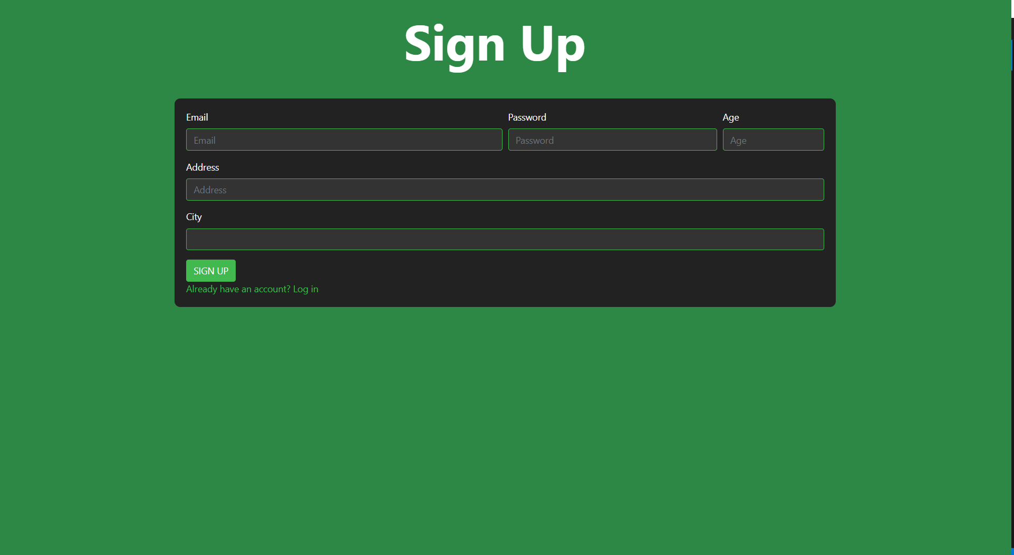

Sign In page:

The registered users are allowed to sign in through here. The values are compared with the values in the database and if they are correct then the user is allowed to login.

Dashboard page:

This is the page main of the website as it consists of all the albums, logout button and the subscription button. From here the user can be allowed to access the whole app.

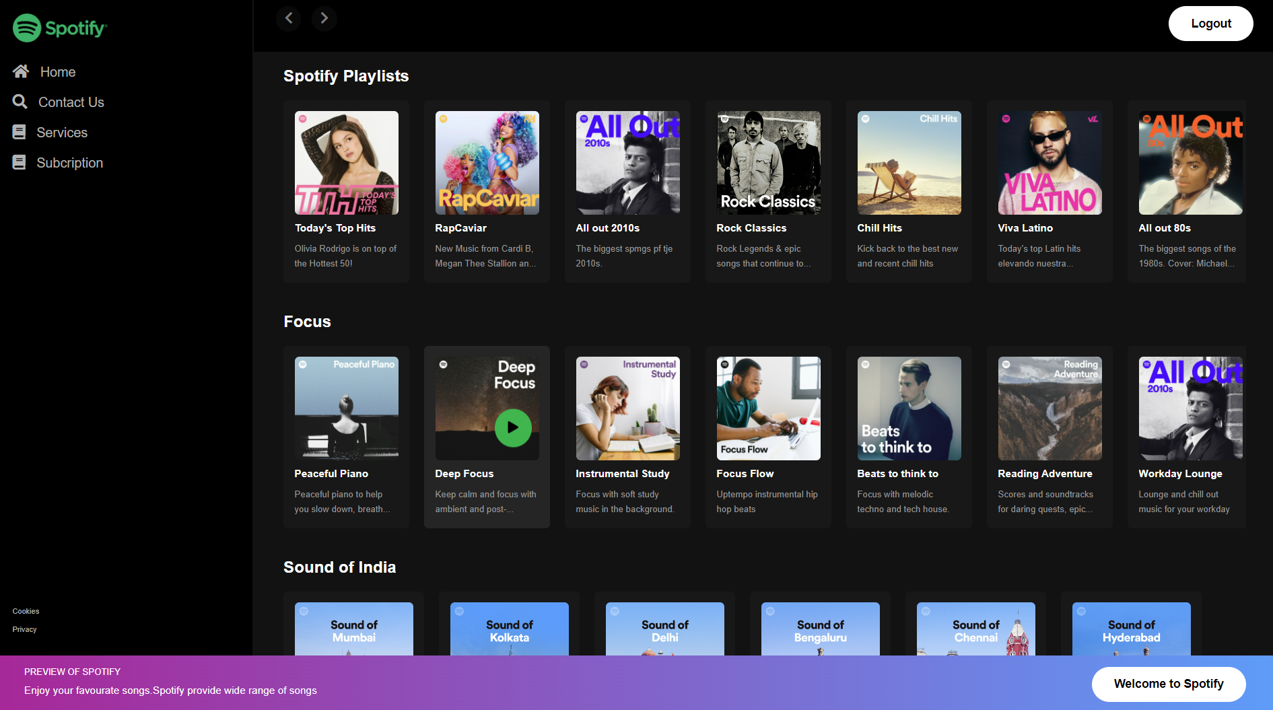

Artist page:

This is one of the artists page, this page allows you to play and pause songs of the given artist. This here consist of the library of songs.

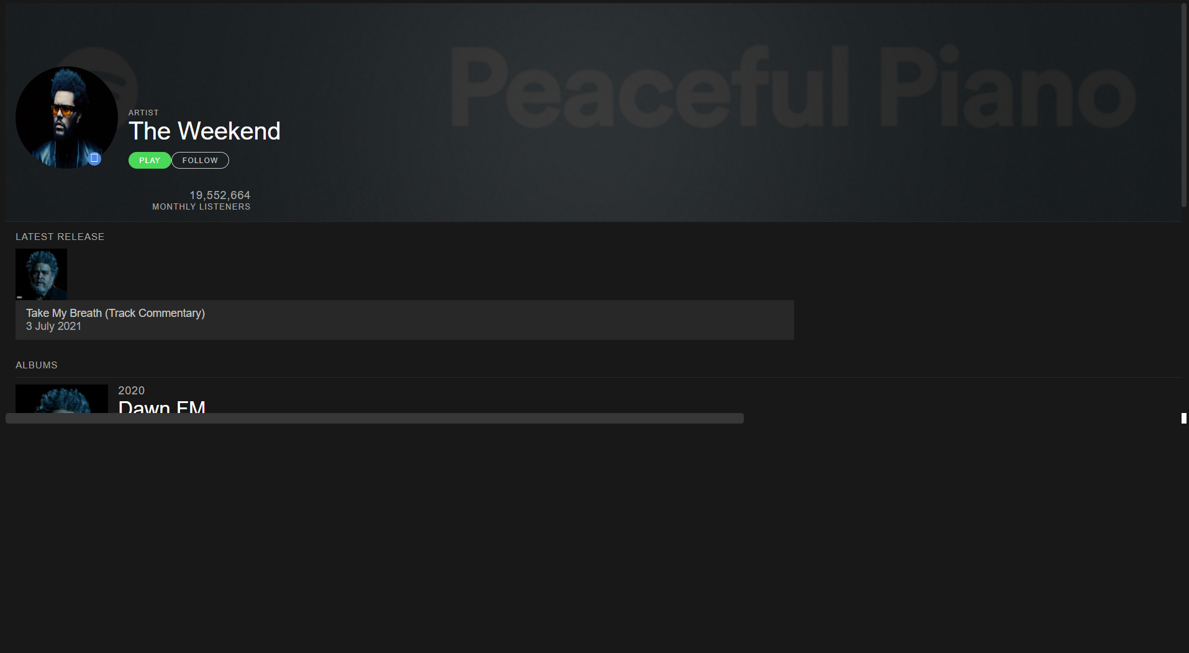

Subscription Page:

This page shows the different plans the user will be able to chose from, It can be bought on a monthly or yearly basis.

Subscription Form:

The user is supposed to enter their information in the following form and an email will be sent to them congratulating them on their purchase.

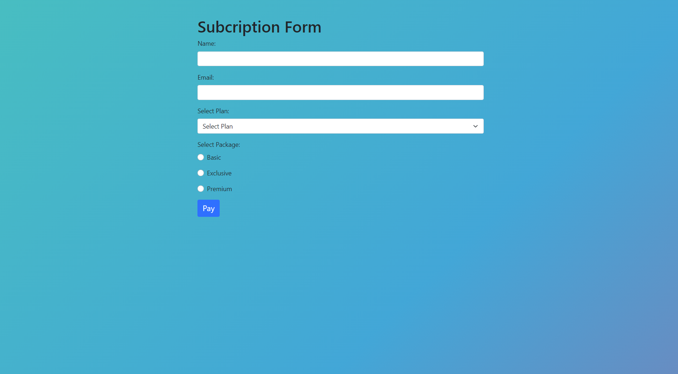

5. Accessibility

5.1 Installation of VS Code

A step-by-step guide is provided for the installation of Visual Studio Code, the preferred code editing tool for the Spotify Clone project. This ensures that developers can easily access and modify the source code for future enhancements.

5.2 Installation of XAMPP

Detailed steps outline the installation process of XAMPP, an essential tool for local server deployment. This comprehensive guide ensures that developers can set up a local environment for testing and development purposes.

5.3 Basic CSS Files

Guidance is provided on creating and utilizing CSS files in VS Code, emphasizing the importance of styling for a visually appealing interface. Best practices in CSS are highlighted, ensuring consistency and maintainability in the codebase.

5.4 Link to GitHub

A direct link to the GitHub repository is included, allowing users and developers to access and explore the project source code. This transparency encourages collaboration, feedback, and further contributions to the ongoing development of the Spotify Clone.

6. Results

6.1 The Final Creation

The Spotify Clone project culminates in a fully functional music streaming website, showcasing not only the technical proficiency in database management and web development but also an acute understanding of user experience design. The user interface is not just functional but also visually appealing, providing an immersive music exploration experience for users.

6.2 Conclusion

In conclusion, the Spotify Clone project stands as a valuable learning experience, demonstrating the effective integration of technologies to create a sophisticated web application. The journey from database design to front-end implementation highlights the practical application of skills learned in the Database Management System course. As developers, the project reflects continuous growth and the ability to create impactful applications.

7. Future Enhancements

The Spotify Clone project serves as a solid foundation for future enhancements. Areas for improvement and expansion may include: